**Tube-segmentation and registration to Allen-Mouse brain Atlas (ABA)**

**CONTENTS**

**PART-1: Tube-segmentation**

**1) Bruker-Import**

**2) Check files**

**3) Make copy of the t2w-image and name it “t0.nii”**

**4) Isolate mouse brains: draw masks manually**

**5) Check animal-masks via “seganimal.jpg”-image**

**6) SPLIT TUBE DATA: Isolate mouse brains and make animal-specific data sets (folders)**

**Scenario**

-several skull-stripped brains in one MRI-volume

-different orientation of animal brains in the bore

(Part-1): Tube segmentation …isolation of animal brains

(Part-2): Registration to ABA

**Prerequisites**

-Templates: using ‚**mouse_Allen2017HikishimaLR**‘

-make project-folder (here: ‘wu_segissue_feb2022’)

- start ANT-gui and set current working directory to project-folder path

-load project (m-file)

**PART-2: Registration to Allen Mouse brain atlas (ABA)**

**1) Check orientation**

**2) Set parameters for animals with orientationType =7**

**3) Perform first two registration-steps for animals with orientationType =7**

**4) Set parameters for animals with orientationType =11**

**5) Perform first two registration-steps for animals with orientationType =11**

**6) Perform the last two registration steps (segmentation + warping) for all animals in one step.**

**7) Create HTML-pages for quality check**

**PART-1: Tube-segmentation**

**1) Bruker-Import**

-go to ANT-MENU: **MAIN/import Bruker data**

-select ‘**raw’**-folder from left box (this folder will then appear in the lower box).

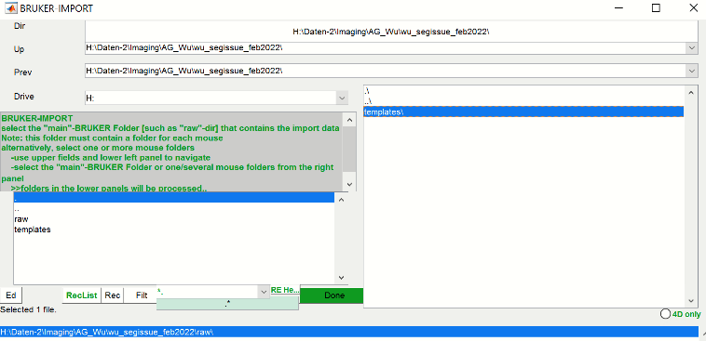

Hit “**Done**”.

-In the file-selection GUI select all files (shortcut: **ctrl+A**). Hit “**OK**”.

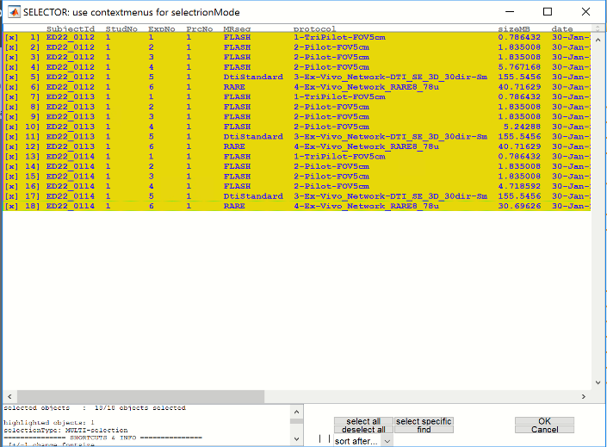

In the parameter-GUI, just hit “**RUN**”.

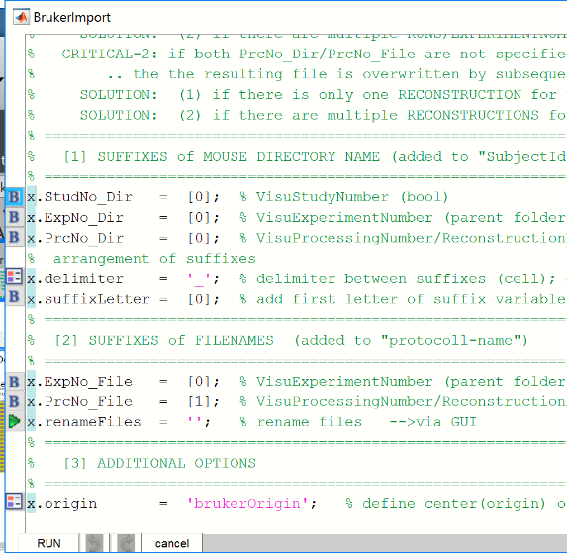

**2) Check files**

-The left list box in the ANT-GUI shows 3 datasets. Select all datasets (ctrl+A).

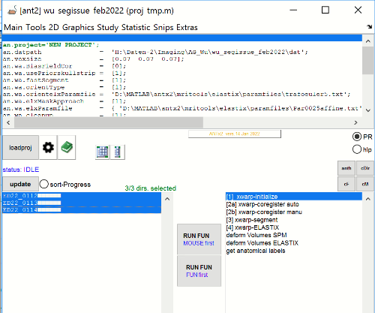

-Hit “**show case-file-matrix**” icon (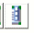, 4th button left to “loadproj”-button).

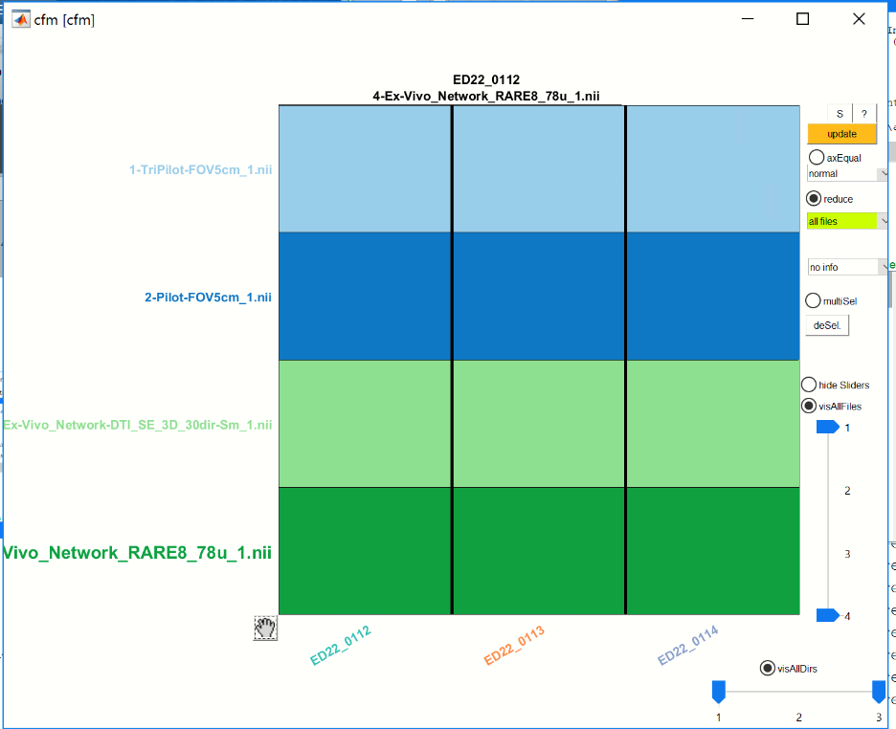

… -use -/+-keys to change font size

Here we have 3 datasets (‘ED22_0112’, ‘ED22_0113’ and ‘ED22_0114’) each of these sets contain the following files:

**1-TriPilot-FOV5cm_1.nii** : not used …can be deleted

**2-Pilot-FOV5cm_1.nii** : not used …can be deleted

**3-Ex-Vivo_Network-DTI_SE_3D_30dir-Sm_1.nii** : 4D-DTI-data volume

**4-Ex-Vivo_Network_RARE8_78u_1.nii** : t2w-volume (3D)

**“4-Ex-Vivo_Network_RARE8_78u_1.nii”** and “**3-Ex-Vivo_Network-DTI_SE_3D_30dir-Sm_1.nii”** are in the same space (so no registration is necessary) . But, here is the problem: When opening “4-Ex-Vivo_Network_RARE8_78u_1.nii” from one data-set (via MRicron) we see (1): there are 2 animals in one volume, and (2) the volume contains ex-vivo skull-stripped brains.

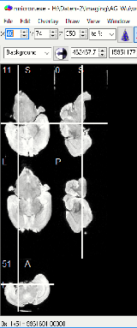

For registration with Allen Mouse brain atlas, we have to isolate the single mouse brains.

**3) Make copy of the t2w-image and name it “t0.nii”**

-To make it easier we will create a copy of “**4-Ex-Vivo_Network_RARE8_78u_1.nii**” and name it “**t0.nii**”.

-For this, again, select all datasets from left list box

-Then, go to ANT-MENU: **Tools/manipulate files**.

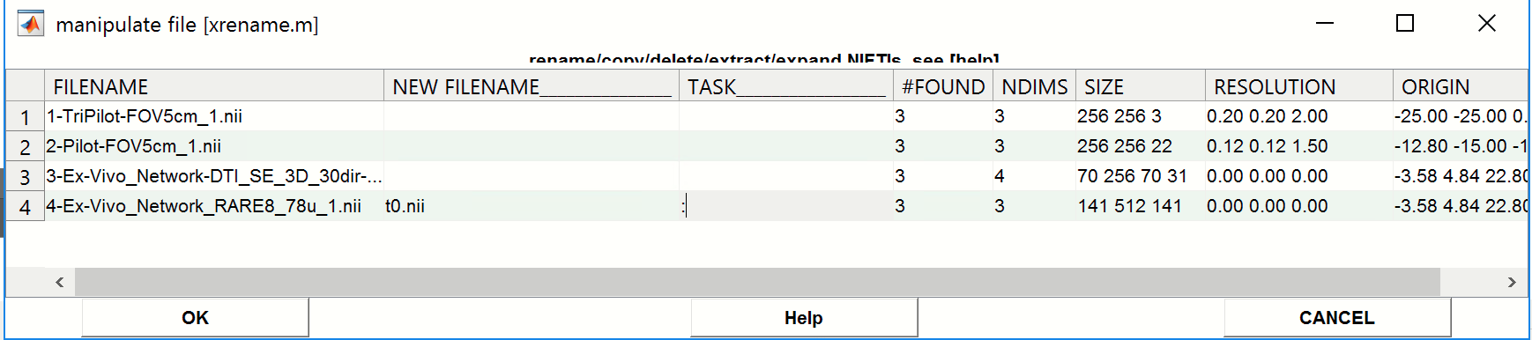

For “4-Ex-Vivo_Network_RARE8_78u_1.nii” :

- enter “**t0.nii**” in the “NEW FILENAME”-column (…this is the new filename of the copied file)

- enter “**:**” in the “TASK”-column (…this means: make a copy of the file, instead of renaming the orig. file)

🡪 This step will make a local copy of the file “4-Ex-Vivo_Network_RARE8_78u_1.nii” for all datasets with the new name “t0.nii”

- Hit “**OK**”.

**4) Isolate mouse brains: draw masks manually**

- select all animals from ANT-left list box

- go to ANT-MENU: **Tools/[1b] segment tube manually**

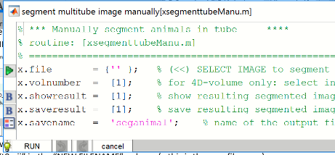

-select icon left of the “**x.file**”-parameter

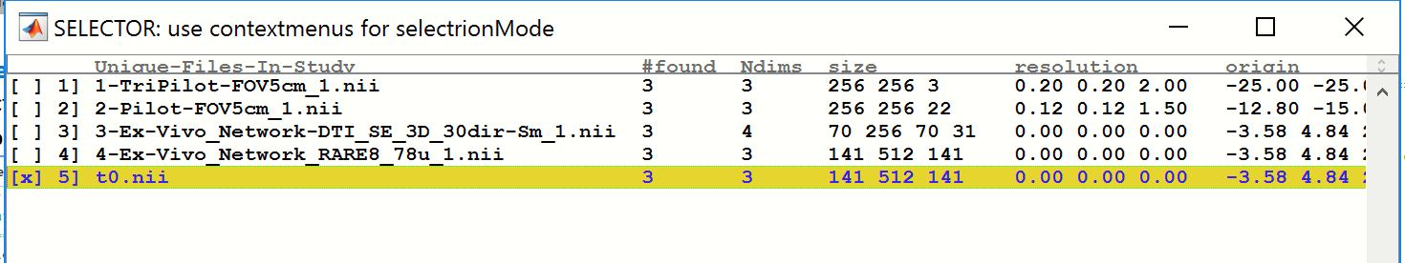

In the file-selection-GUI select the “**t0.nii**”-image. Hit “**OK**”.

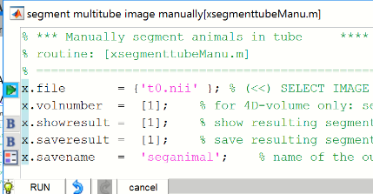

Hit “**Run**”. This will open the manual tub-segmentation GUI.

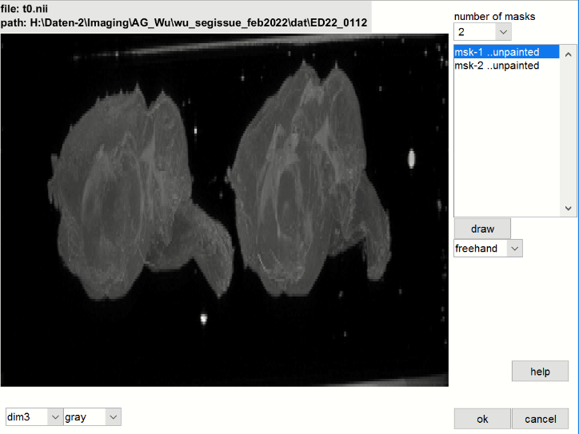

-Here, first check the number of animals seen in the volume. Here we have two brains. Because we need **two** masks, set the “**number of masks**” to 2 (pulldown). Change the dim-pulldown menu if you want to see the volume from another dimensional view. Here, “dim3” seems to be fine here.

**Draw the mask for the 1st brain:** Now we select **“msk-1” ..unpainted”** from the right list box, and select “**freehand**” (below the “draw”-button). The other option, drawing a “rectangle” (instead of “freehand”) is not possible here, because the brains are to close towards each other.

Hit “**draw**”-button. Now draw a mask to isolate the 1st brain. When done, hit “**accept**”.

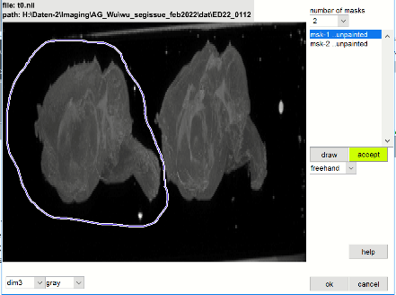 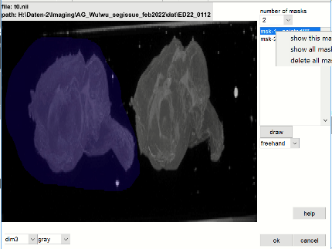

Using the right list box’s contextmenu you can show the current mask

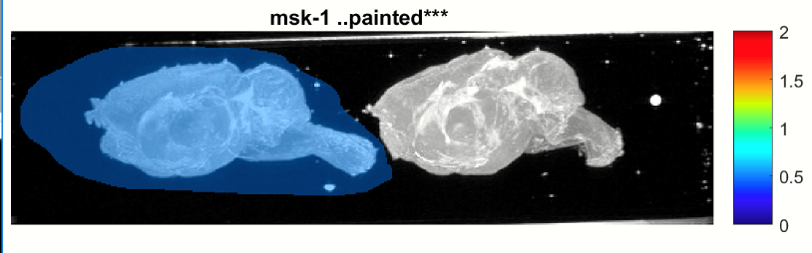

..but you can also delete the current mask via the context menu and restart drawing the mask…

**Draw the mask for the 2nd brain:** Now select **“msk-2” ..unpainted”** from the right list box , hit the “**draw**”-button and draw the mask for the 2nd brain. When done, hit “**accept**”-button.

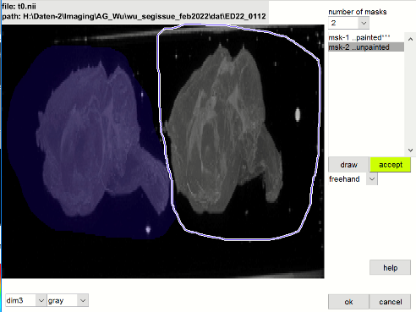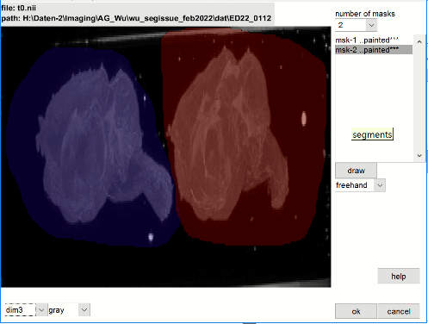

Using the right list box’s contextmenu and select “**show all masks**” to visualize the masks for the 1st dataset.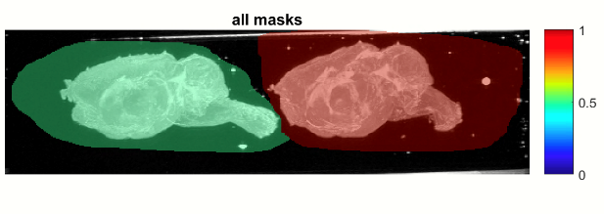

When Done, hit “**OK**”.

**Important here: Previously we have selected all datasets (3). Thus this GUI will be reopened for the 2nd and 3rd dataset after hitting “ok”. In ther words, you have to draw the masks for the 2nd and 3rd dataset as well. …**

..masks for the 2nd dataset:

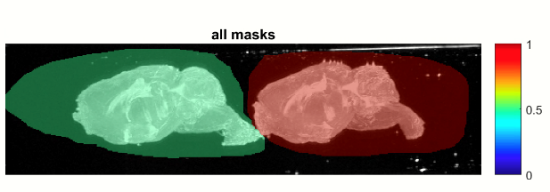

…and masks for the 3rd dataset:

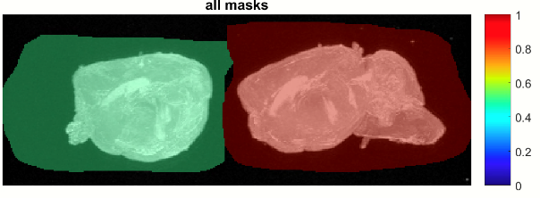

When done, you can select the **“MRicron”-hyperlink** from the comand-window to visalize the masks:

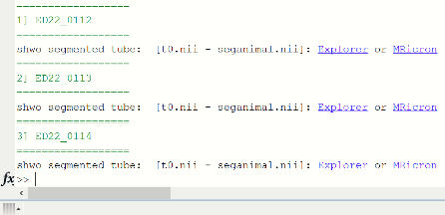

Below are the masks for the three datasets. Note that the orientation of the brains within each volume is approximately similar. However the orientation for dataset-1 is **different** compared to the datasets -2 and -3. This issue will be dealt later in the ABA-registration part.

|  |  |  |
| --- | --- | --- |
|  |  |  |
| ED22_0112 | ED22_0113 | ED22_0114 |

**5) Check animal-masks via “seganimal.jpg”-image**

-OPTIONAL: Check whether the masks for separation of animal brains are ok: For this, open each dataset-folder manually or select the datasets (ED22_0112, ED22_0113 and ED22_0114) from the left list box and click the list box’s context-menu/”**open folder in explorer**”. For each of these folders inspect the “seganimal.jpg”-image

Here, the animal specific masks (green and red) look ok (i.e the masks cover the respective brains).

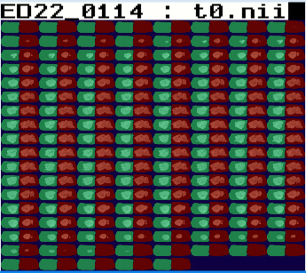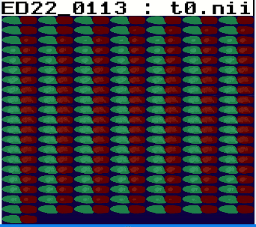 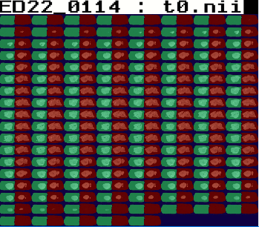

**6) SPLIT TUBE DATA: Isolate mouse brains and make animal-specific data sets (folders)**

- select all animals from the ANT-left list box

- go to ANT-MENU: **Tools/[2] split tube data**

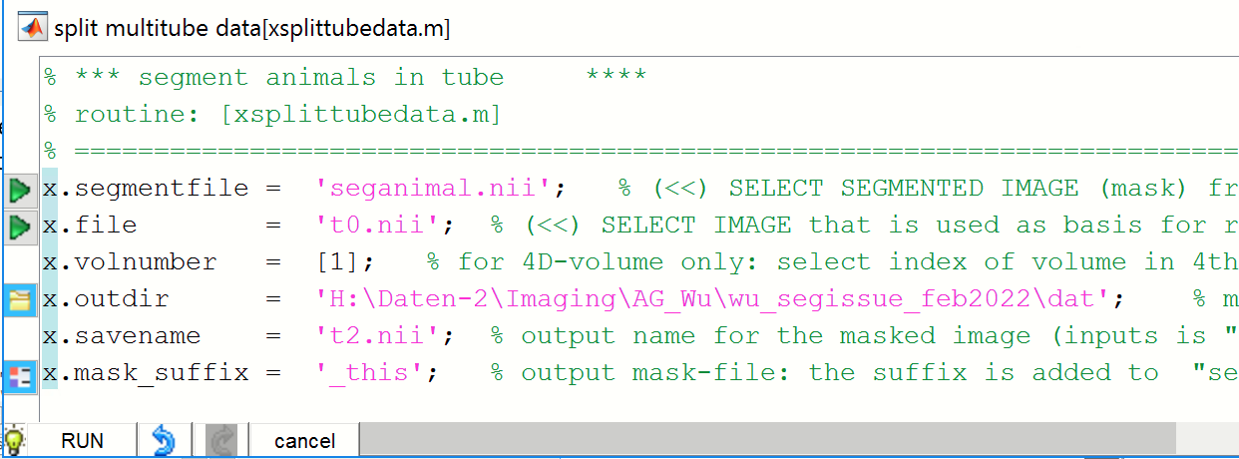

-Select the icon left to the “**x.outdir**”-parameter and select the current “**dat**”-folder there (see figure).

Hit “**RUN**”.

🡪 This procedure will create animal-folders based on the delineated masks in the previous steps. The new animal-folders will be located in the current “dat”-folder (as specified by “**x.outdir**” -parameter). The new animal names will be constructed by: dataset-name + “_” + mask-number (example: ”ED22_0112_1” or “ED22_0112_2” )

-Hit the ANT “**update**” button.

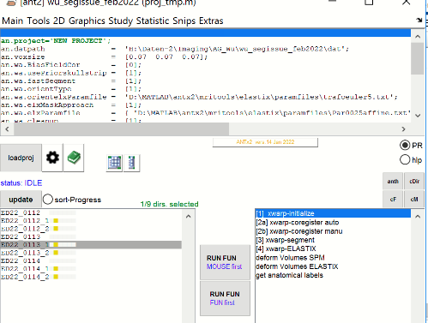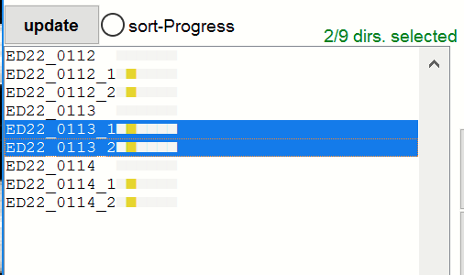

We see that for each of the datasets 2 additional datasets were created (“*_1 and” “*_2” ), which represents the isolated animal-data. Note that we can only register the isolated brains to the Allen brain atlas (ABA, thus we are now only interested in the “*_1 and” “*_2” datasets (not the original data sets). For this, there are three options possible:

a) remove/delete the original datasets (‘ED22_0112’, ‘ ED22_0113’, ‘ED22_0114’)

b) export the (“*_1 and” “*_2” ) folders and create a new project to register the brains to ABA: For this, first select all “*_1 and” “*_2” data-sets. From the list box’s context menu select “export folder” and select/create&select a target directory

c) Keep all folders as are.

Here we go for option-c but must secure that the right animals will be selected from the left list box for ABA-registration.

**PART-2: Registration to Allen Mouse brain atlas (ABA)**

**1) Check orientation**

-**IMPORTANT**: Here we have to determine the rough orientation of the animals. Note than in a standardized study all animals of the same study are positioned with the same orientation in the bore. In this case, usually the orientation of only one animal has to determined (assuming that the other animals have roughly the same orientation).

Here, however, the orientation is **different** for each tube and possibly for each animal within each tube. **Therefore, we have to check and determine the orientation for every dataset.**

-select the 1st animal of the first dataset (“**ED22_0112_1**”).

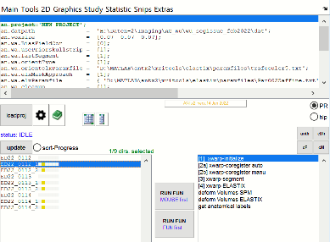

Note: If the “**template**”-folder in the current study-folder ( “wu_segissue_feb2022”) does **not** exist, select **MAIN/Create study templates from the ANT-MENU**. This will create the template-folder containing all necessary template-images with the wished voxel-resolution. Otherwise (if the template-folder exists), skip this step.

-From the context menu of the animal list box select **“examine orientation”.** This step may take some time, because the images (t2.nii) are very large.

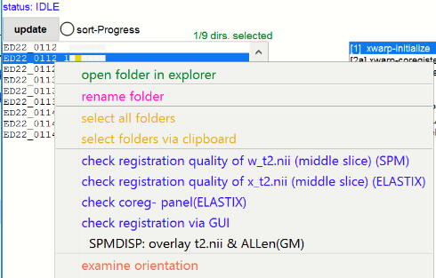

For ED22_0112_1 we select the rotation-table ID: [7]. This is the orientationType.

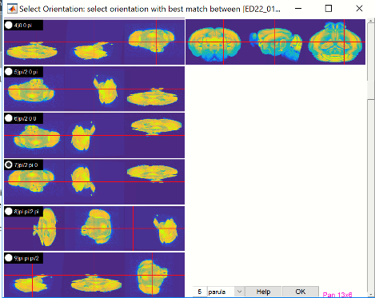

Now select the next animal and select “**examine orientation**” (context menu)..**do this for all animals**…

For “ED22_0112_2” we select the rotation-table ID: [7] …same as for ED22_0112_1

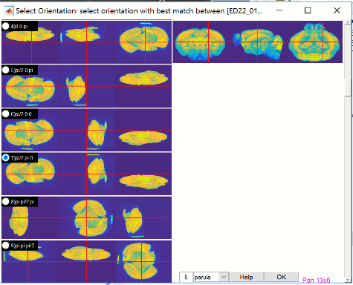

For “**ED22_0113_1**” we select the rotation-table ID: [11]

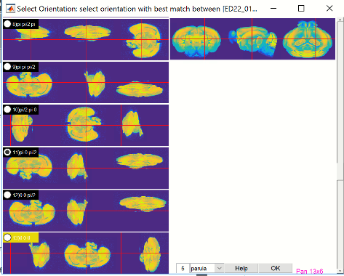

For “**ED22_0113_2**” we select the rotation-table ID: [11] …same as for ED22_0113_1

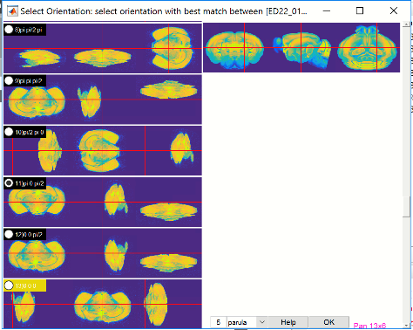

For “**ED22_0114_1**” we select the rotation-table ID: [11] …same as for ED22_0113_1

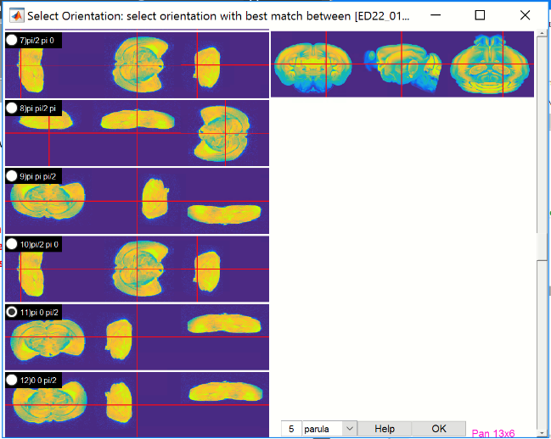

Note: This is a tricky one (… not sure here), but we can try and check whether this works…

For “**ED22_0114_2**” we select the rotation-table ID: [11] …same as for ED22_0113_1

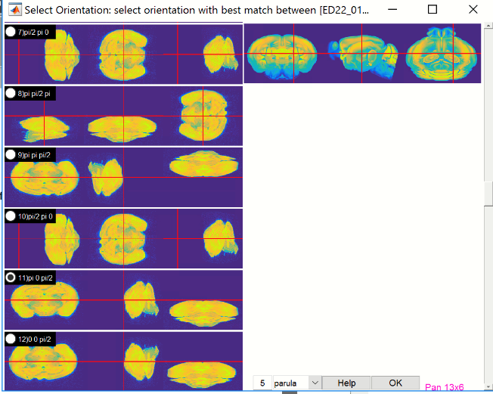

**To recap: From six animals we have two animals with the orientation-Type=7 and four animals with orientation-Type =11.**

**Because of the different orientationTypes across animals the fastest to perform the ABA-registration is as follows:**

1) perform the **first** **two** registration-steps (initialization+coregister auto) for animals with orientationtype-7

2) perform the **first** **two** registration-steps(initialization+coregister auto) for animals with orientationtype-11

3) perform the **last two** registration steps (segmentation+warping) for **all animals in one step**.

**All steps are described bellow, but here is the reasoning:** The critical issue is the “coregister auto”-step that is strongly depending on the orientationType. In some animals, one has to try another orientationType (use context-menu/ “**examine orientation**”. If this step is too difficult to examine, use context-menu/ “**get orientation via 3 point selection**”).

If the first two steps are fine (inspect first), the last two steps will most likely successful.

**2) Set parameters for animals with orientationType =7**

-click wheel icon () next to the “loadproj”-button:

Set the following paramters:

x.wa.BiasFieldCor = [0];

x.wa.usePriorskullstrip = [0];

x.wa.fastSegment = [1];

x.wa.orientType = [7]; 🡨 this is the OrientationType,…must be set to 7!

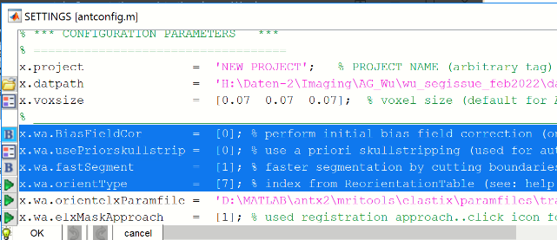

-Hit “**OK**”.

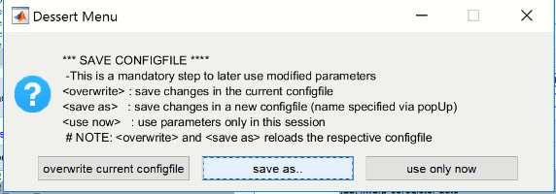

-Hit “**save as**”-button

-save new project-file as “**proj_orientationType7.m**”. Hit “**save**” (german: speichern).

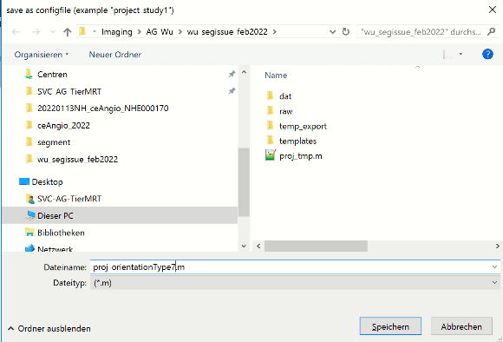

The upper list box should now show the updated parameters. If not load the project-file “**proj_orientationType7.m**” via “**loadproj**”-button.

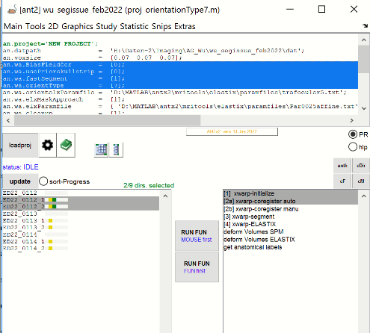

**3) Perform first two registration-steps for animals with orientationType =7**

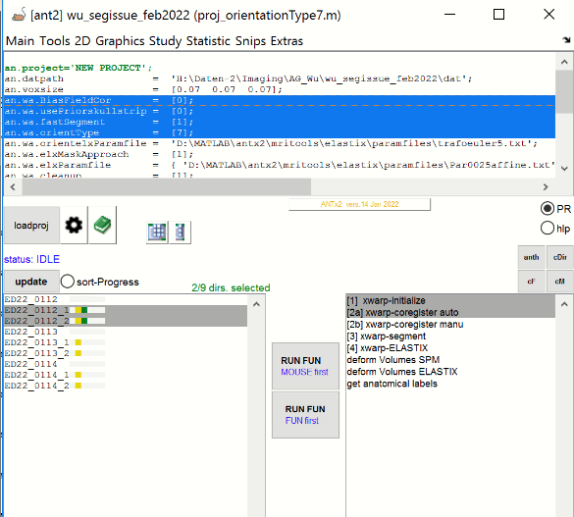

-select “**ED22_0112_1**” and “**ED22_0112_1**” from the left animal box.

-select the first two registration steps **(“[1]xwarp-initialize”** and **“[2]xwarp-coregister auto”** )

- hit **lower** “**RUN FUN”** button (If parallel processing TBX is available, you can alternatively hit the **upper “RUN FUN”** button to accelerate the processing time).

-During processing… If the HTML-progress report is not open, select **“summary.html”** from the studies folder.

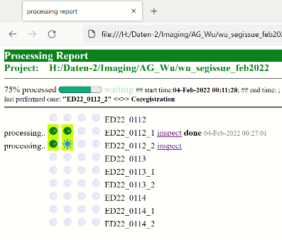

-Here, the first two steps (green bullets) are finished for the 1st animal (“ED22_0112_1”). Select “inspect” from this animal and scroll the HTML-page down to the coregistration-section and click onto the image to see (toggle images: template and this animal) whether the (rough) coregistration worked.

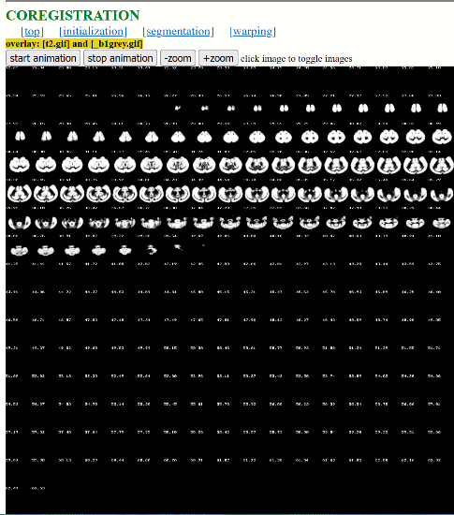 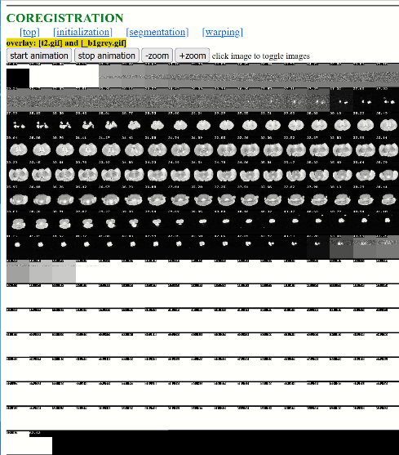 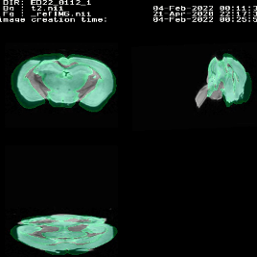

…coregistration for “**ED22_0112_**1” seems to be ok..

Do the same for “**ED22_0112_2**”). Registration worked here too.

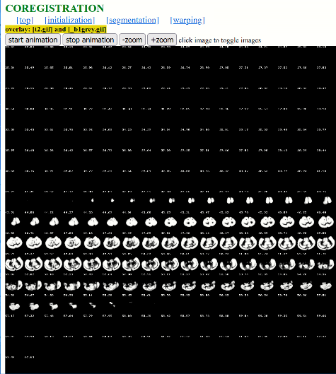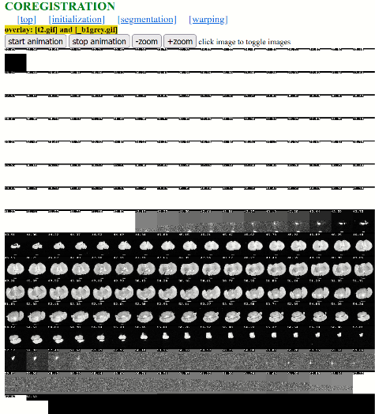 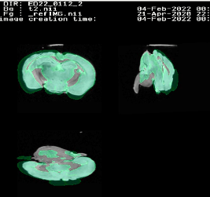

**4) Set parameters for animals with orientationType =11**

-Click wheel icon () next to the “loadproj”-button:

**Set the following paramters:**

x.wa.BiasFieldCor = [0];

x.wa.usePriorskullstrip = [0];

x.wa.fastSegment = [1];

x.wa.orientType = [11]; 🡨 this the OrientationType,…must be set to 11!

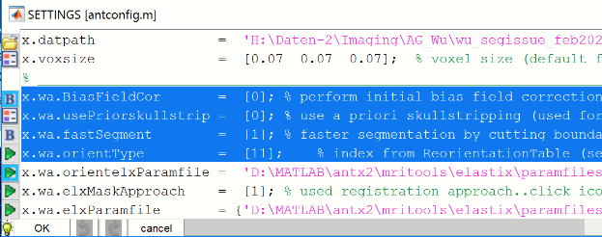

-Hit “**OK**”.



-Hit “**save as**”-button

-Save new project-file as “**proj_orientationType11.m**”. Hit “**save**” (german: speichern)

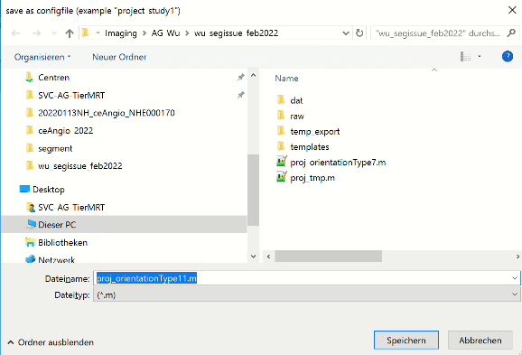

The upper list box should now show the updated parameters. If not load the project-file “**proj_orientationType11.m**” via “**loadproj**”-button.

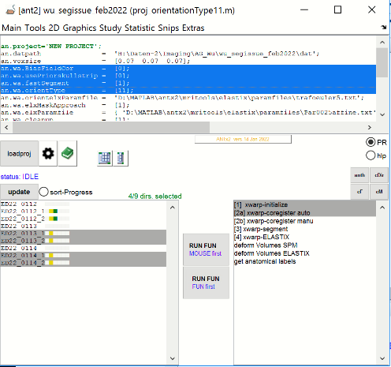

**5) Perform first two registration-steps for animals with orientationType =11**

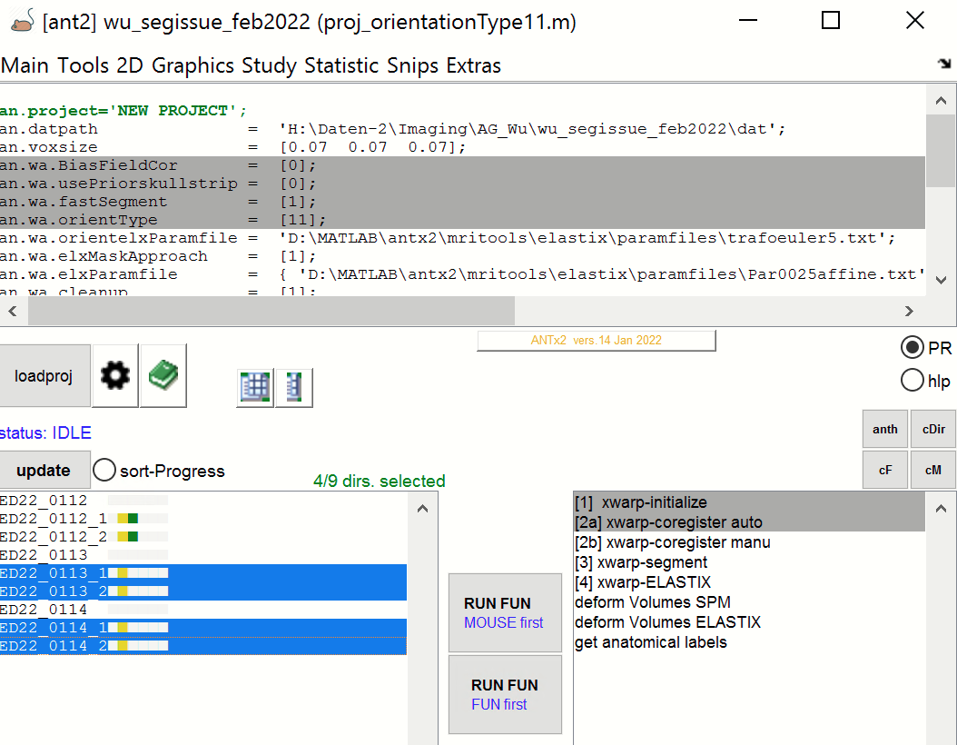

-select the animals corresponding to **orientationType=11** from left animal box:

**“ED22_0113_1”, “ED22_0113_2”, “ED22_0114_1” and “ED22_0114_2**”

-select the first two registration steps: **“[1]xwarp-initialize”** and **“[2]xwarp-coregister auto”**

- hit lower “**RUN FUN**” button (**If parallel processing TBX is available, you can alternatively hit the upper “RUN FUN” button to accelerate the processing time**).

-During processing… If the HTML-progress report is not open, select the “**summary.html**” from the studies folder.

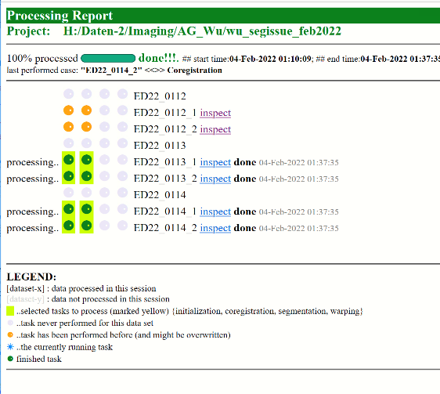

-check via “**inspect**”-hyperlink

Registration of “**ED22_0113_1**” seems to work:

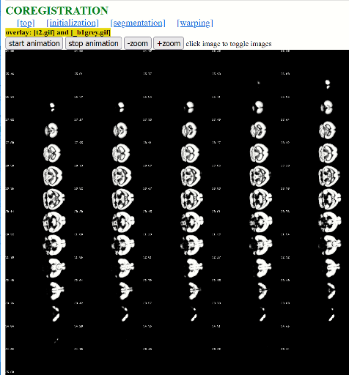 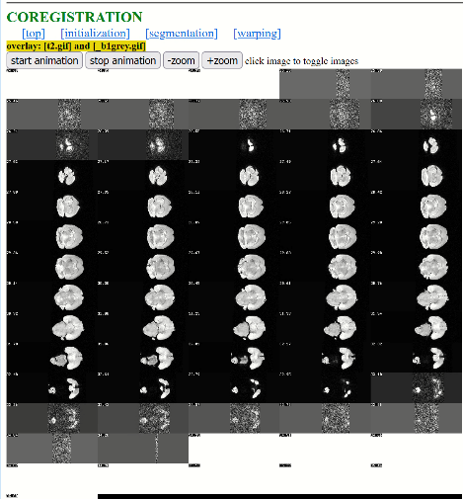 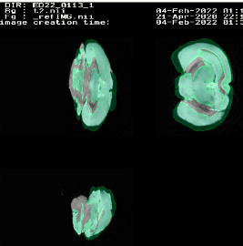

Registration of “**ED22_0113_2**” seems to work:

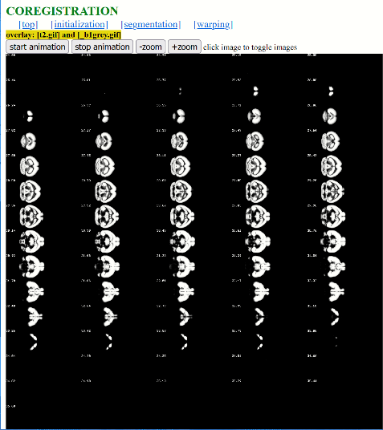 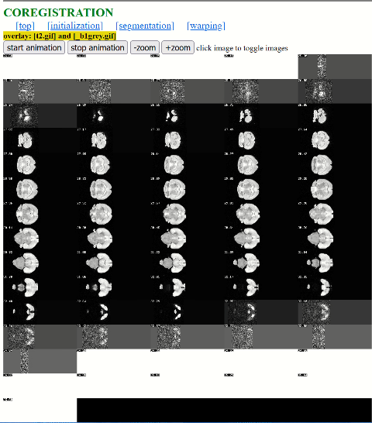 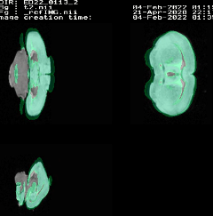

Registration of “**ED22_0114_1**” seems to work:

Note that posterior parts of the brain are missing (cerebellum) … probably physically lost before MRI-acquisition

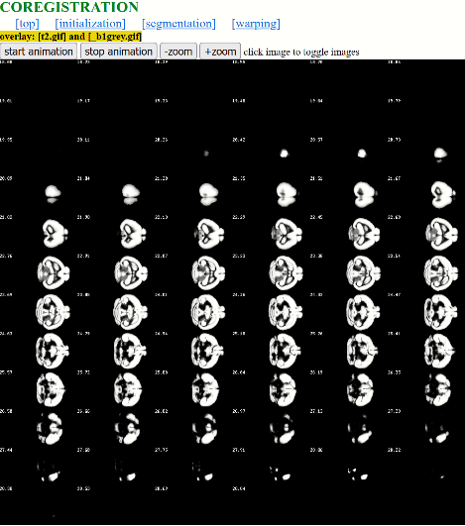 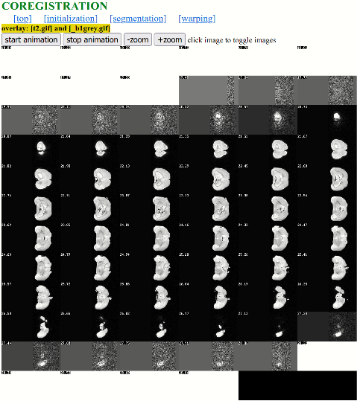 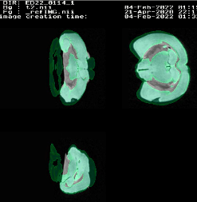

Registration of “**ED22_0114_2**” seems to work:

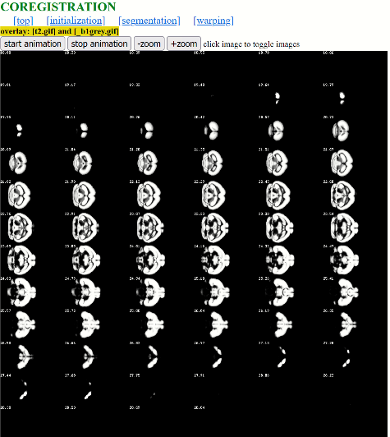 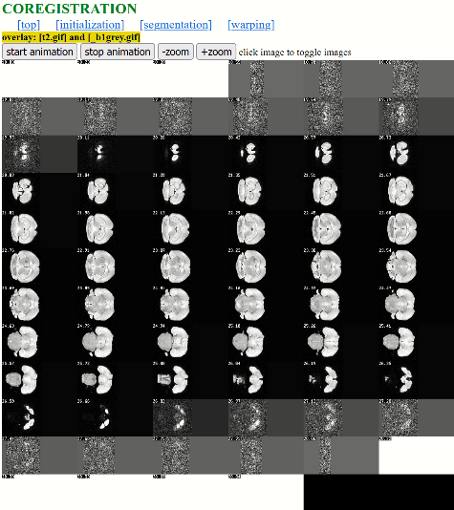 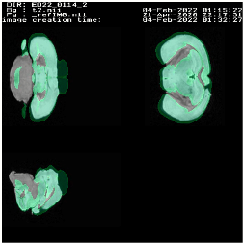

**6) Perform the last two registration steps (segmentation + warping) for all animals in one step.**

🡪 Segmentation and warping images (**'[3] xwarp-segment'** and '**[4] xwarp-ELASTIX'**) will be now performed for all animals.

- Note that for these two steps it does not matter which of the project-files (“proj_orientationType7.m” or “proj_orientationType11.m”) is used. The only difference between the two project-files is the orientationType (7 vs 11). The orientationType parameter is in fact critical for the '[2a] xwarp-coregister auto'- step (rough rigid coregistration) only.

-now, select **all** animals (‘*_1’ and ‘*_2’ -folders) from the animal list box

-select the steps **'[3] xwarp-segment'** and **'[4] xwarp-ELASTIX'**: from the right list box.

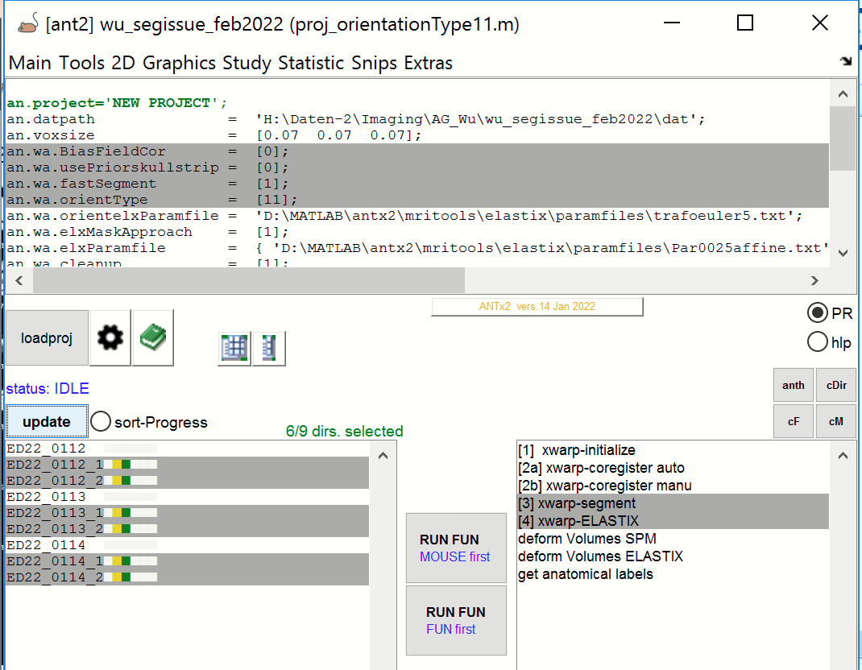

- hit lower “RUN FUN” button (**If parallel processing TBX is available, you can alternatively hit the upper “RUN FUN” button to accelerate the processing time). Here I use the upper “RUN FUN”-button**

**-this procedure will take some time (large images)…**

-during or after processing you can inspect the segmentation and deformation status for each animal by opening the processing report (“summary.html”-file in the project folder.

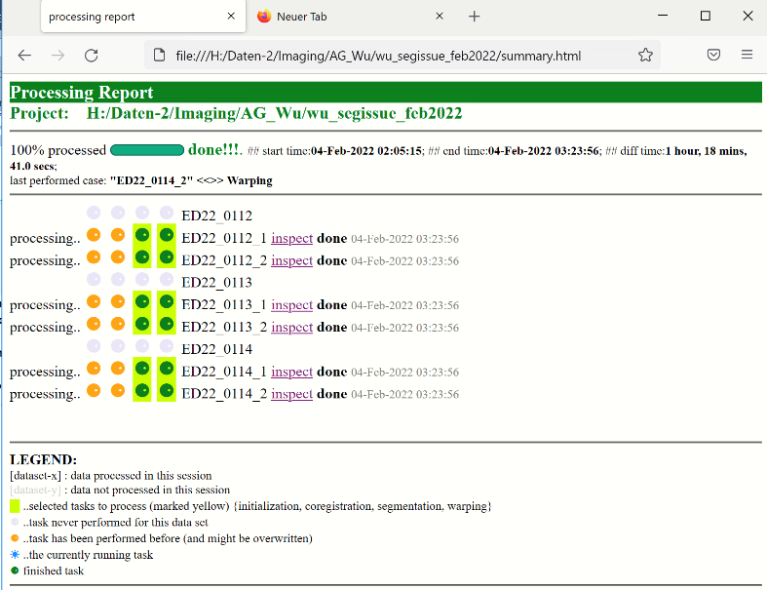

Here, the two last tasks (green bullets) have been performed for all animals. Go to the ‘**inspect’**-link to check the animal’s segmentation and warping results. Click onto the image to toggle between t2w-image and gray-matter tissue compartment (segmentation session) or between t2w-image in standard space and ABA-template.

Segmentation of ‘**ED22_0112_1’**: t2w-image (“**t2.nii**”, left) and gray-matter tissue compartment (“**c1t2.nii**”, right)

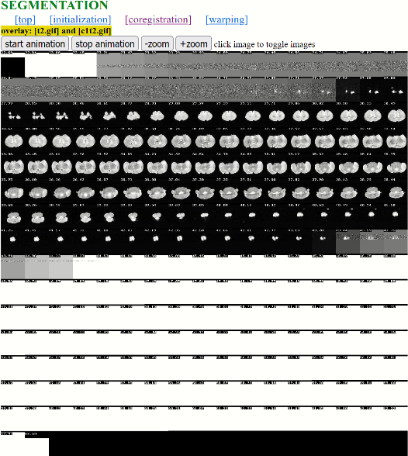 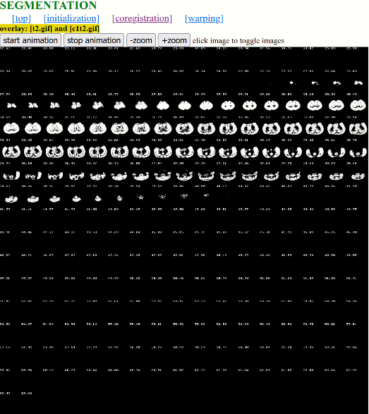

Warping of ‘**ED22_0112_1’**: t2w-image (“**x_t2.nii”**, left) and ABA-template (“**AVGT.nii**”, right) in standard-space

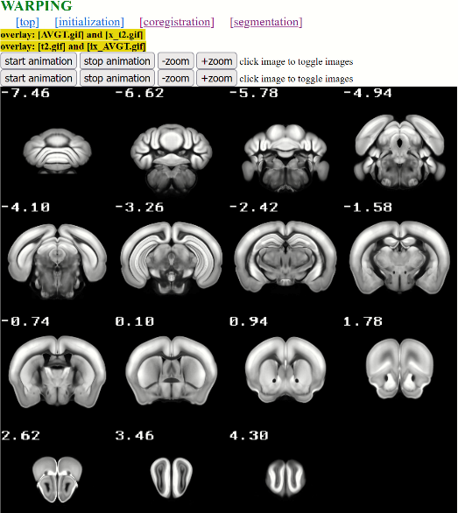 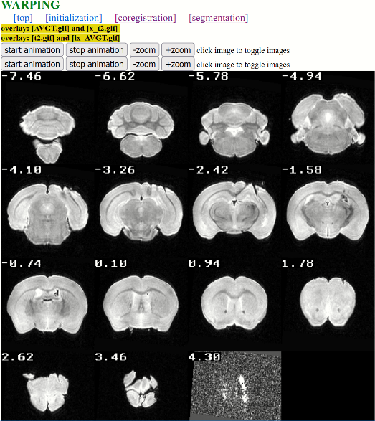

…you can do this for all animals or create a HTML-pages to obtain the registration for all (or a number of selected) animals in one step (see below).

**7) Create HTML-pages for quality check**

**1) make HTML-page for segmentation:**

…-select ann animals (those with ’*_1’ and ‘*_2’) from the left listbox:

- from ANT-MENU select **“GRAPHICS/generate HTML-file with overlays”**

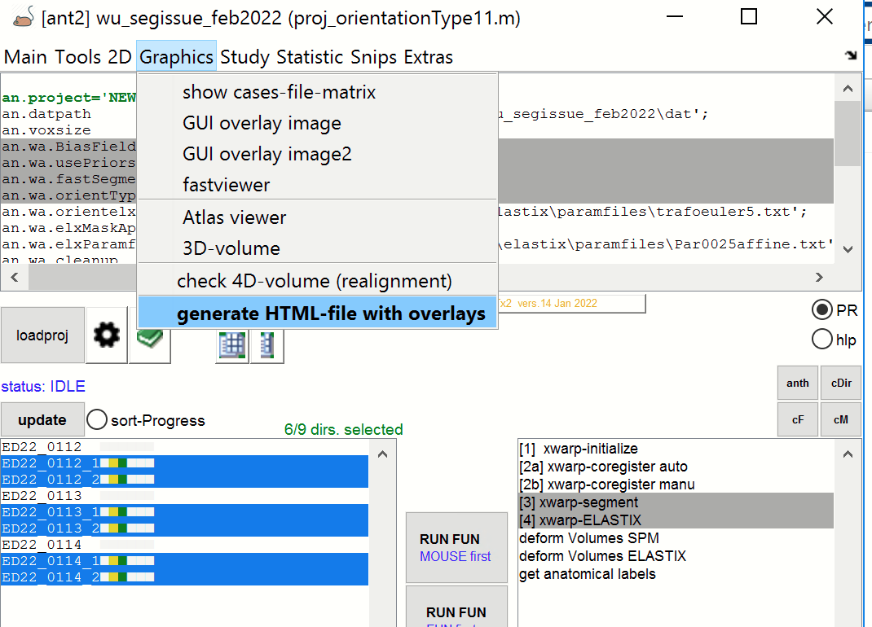

- for “x.backgroundImg” (via green icon): select “**t2.nii**” as background-image

- for “x. overlayImg ” (via green icon): select “**'c1t2.nii**“ (gray-matter image) as image to overlay

- for “x. outputPath” (via green icon): go to the study-folder and create a new folder “**checks**” and select this folder

- for “x. slices” enter “**n20**”, to plot 20 slices

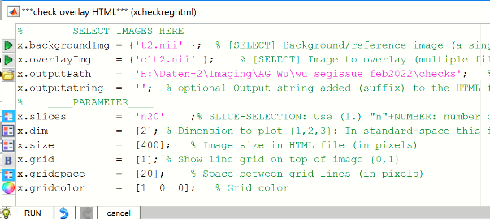

Hit “**RUN**” and wait. Note that this may take some minutes, because the images (“**t2.nii**” and “**c1t2.nii**”) are derived from the animal’s native space.

When done, click the “**open**”-hyperlink next to the checkRegHTML in the command window to inspect the results

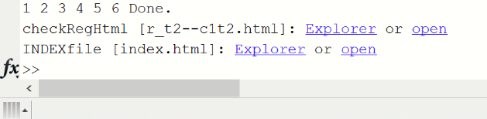

The HTML-file contains the overlay (“**t2.nii**” and “**c1t2.nii**”) for all animals: Click onto the left image to toggle between foreground and background image. Use shortcut **ctrl & +/-** to zoom in/out of the images.

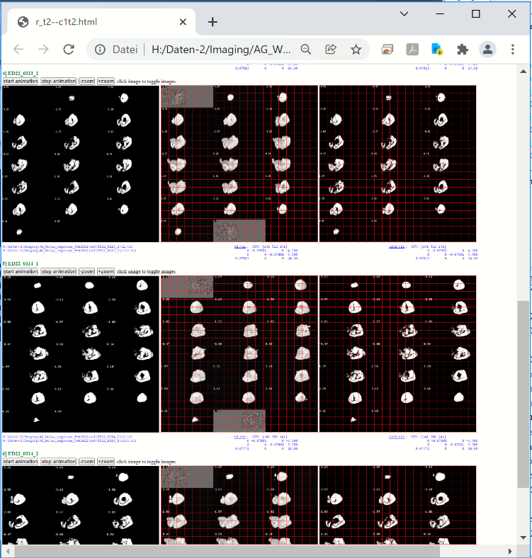

**2) make HTML-page for warping:**

…-select all animals (those with ’*_1’ and ‘*_2’) from the left listbox:

- from ANT-MENU select **“GRAPHICS/generate HTML-file with overlays”**



- for “x.backgroundImg” (via green icon): select “**AVGT.nii**” (the ABA-template) as background-image

- for “x. overlayImg ” (via green icon): select “**x_t2.nii** (this is the “t2.nii” warped to standard space)” as image to overlay

- for “x. outputPath” (via green icon): select the “**checks**”-folder (created in the previous step)

- for “x. slices” enter “**n20**”, to plot 20 slices

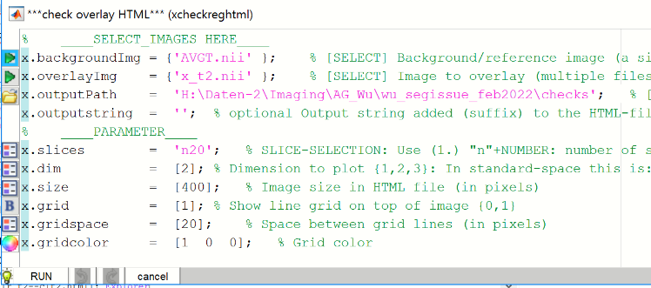

Hit “**RUN**” and wait. Note that the images (“**AVGT.nii**” and “**x_t2.nii**”) are now derived from standard space.

When done, click the “**open**”-hyperlink next to the ‘checkRegHTM’L in the command window to inspect the results.

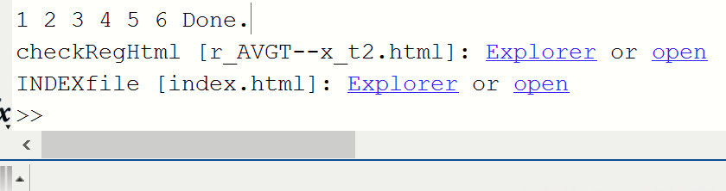

The HTML-file contains the overlay (“**AVGT.nii**” and “**x_t2.nii**”) for all animals: Click onto the left image to toggle between foreground and background image. Use shortcut **ctrl & +/-** to zoom in/out of the images

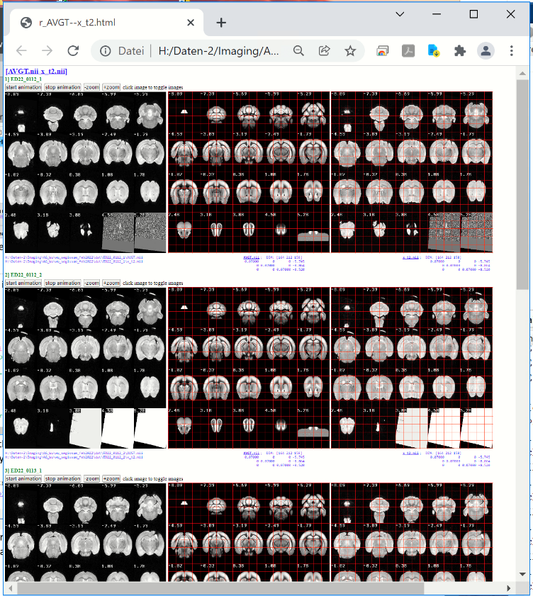

**-open the “checks-folder” in the explorer-window:**

-Here we have the Html-files with corresponding subfolders (containing the images).

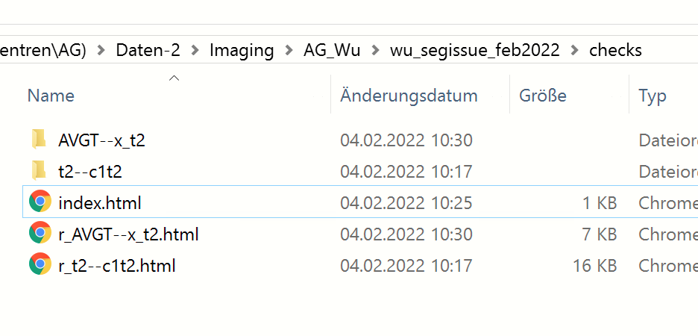

- The index-file (**index.html**) is a summary of all HTML-checks (fast access to the HTML-checkREG files)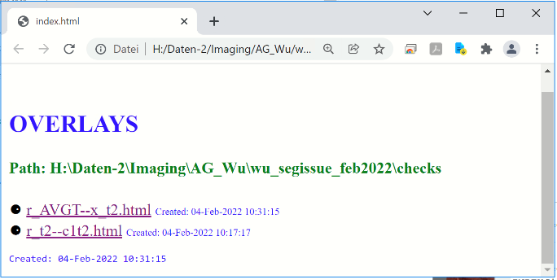

Click onto the link “**r_t2--c1t2**.**html**”to inspect the segmentation results, or “**r_AVGT--x_t2.html**” to inspect the warping results.

**Important**: You can easily extend the list of HTML-check-up files (example: how is the quality of the inverse warping, i.e. how is “ix_AVGT.nii” on top of “x_t2.nii” (both images in native space) ) via “**GRAPHICS/generate HTML-file with overlays**”.

**Important**: The “**checks**”-folder can be zipped and send to your colleagues for quality control (as HTML-sides are supported on most machines).